

**A211 STIA1113 PROGRAMMING 1 (GROUP C)**

LECTURER : Prof. Madya Dr. Azman B Yasin

NAME : NUR ANIS SHAFIQAH BINTI MAZLAN

MATRIC NUMBER : 286987

TOPIC : BANK

SUBTOPIC : PERSONAL ACCOUNT



Since July 1983, Bank Islam Malaysia Berhad has been operating as an Islamic bank in Malaysia. Bank Islam is Malaysia's first Islamic bank, and it has played a significant role in the creation and growth of the country's Islamic financial system. Our current existence is focused on satisfying society's financial demands in the most sustainable and ethical way possible, while adhering to Shariah regulations and principles.

1. **Identify the problem:**

Encik Karim, a retired teacher from SMK Kubang Kerian, was 62 years old. Encik Karim wanted to pay his electric bill at Bank Islam Kubang Kerian in Kota Bharu, Kelantan, last week. Encik Karim was having problems transferring money to Tenaga Nasional Berhad for pay his house electric bill during the COVID-19 epidemic because people were advised to stay at home to prevent getting the virus. Encik Karim is looking for a solution from Bank Islam Malaysia to help him in paying his electric bill.

1. **Understand the problem:**

Our goal at Bank Islam is to create alternatives for everyone and improve their lives. We accomplish this through offering end-to-end financial systems that fit the various requirements of customers, as well as a platform for our stakeholders to grow, including our people, customers, and community.

According to the problem stated, Encik Karim is having problems paying a bill since he is unable to go to Bank Islam. This implies Encik Karim will have to find another way to pay his electric bill without having to go to Bank Islam.

1. **Identify alternative ways to solve the problem:**
2. Create an online service programme (GO Bank Islam) that requires customers to provide their information and allows them to transfer money via phone or laptop.
3. Contact Bank Islam employees and request that money be transferred by providing customer information.
4. **Select the best way to solve the problem from the list of alternative solutions:**



The first way is the best way that can be easier for Encik Karim to transfer his money. GO Bank Islam online service program can assist customer with their problems relating to the option that are available. A program will provide user information related to Recipient Bank, Recipient Account, Recipient Name, Recipient Reference, Amount. This program will lead the user through the process of transferring money and will calculate the total amount transmitted and any fees that may be charged based on the user's request.

1. **List instructions that enable you to solve the problem using the selected solution:**
2. User need to choose DuitNow.

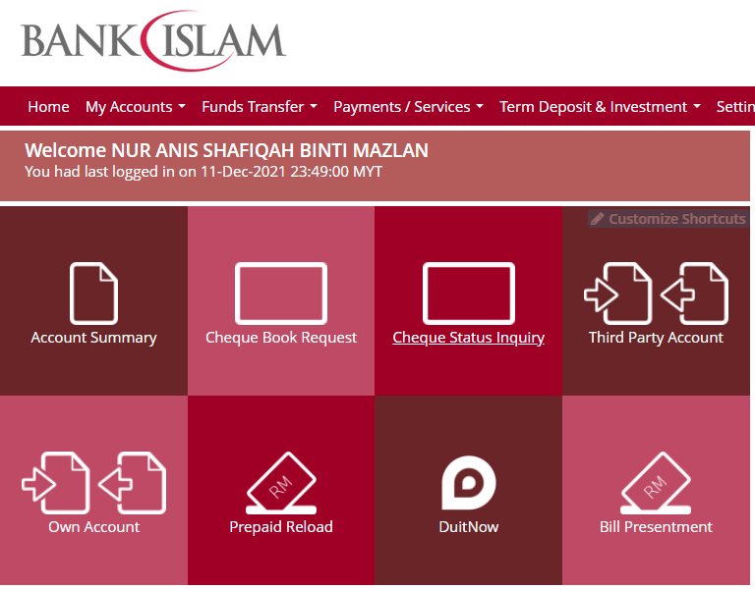

1. Ask user to key in their account number .

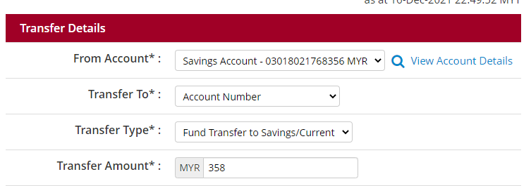

1. The program will display the details needed. (example: Recipient Bank Name, Recipient Account, Recipient Name, Recipient Reference, Amount ).

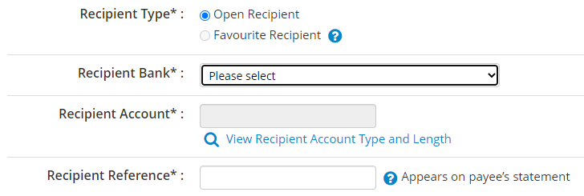



1. Ask user to key in the information needed.
2. The program will calculate the total amount transmitted and fees that have been charged.
3. The program will display the total amount transmitted and fees that have been charged to user.

EXAMPLE :

Account number : 764538

|  |  |  |
| --- | --- | --- |
| OPTION |  | FORMULA |
| DuitNow | Recipient Bank Name : Bank Muamalat  Recipient Account : 63518028  Recipient Name : Salman Bin Aziz  Recipient Reference : For food  Amount : RM176.00  *RM1.00 will be charged.  *Fee = 2% | RM176.00 + RM1.00 + (RM176.00*0.02)  = RM180.52 |

1. **Evaluate the solution**

Based on the solution that have been stated, Encik Karim can pay his electric bill by using GO Bank Islam services and choose DuitNow to transfer the money. Besides, regarding to the situation that Encik Karim or people who need to transfer their money but need to stay at home, also can make transaction money to others by using DuitNow too. They can use it on their phone or laptop at anywhere and anytime.

1. **Algorithm**

1.Choose DuitNow.

2.Insert user account number.

3.Insert recipient bank name.

4.Insert recipient account number.

5.Insert recipient name.

6.Insert recipient reference.

7.Insert transfer amount.

8.Wait until programme finish calculate total amount and fee that been charged.

9.Programme display total amount and fee that been charged.

1. **Pseudocode**

Start

Read next

Read acc

Read bankname1

Read acc1

Read name1

Read reference1

Read amount1

Read next1

Calculate total1 = (amount1+(amount*0.02)+1)

Display total

End

1. **Flowchart**

Read next

Display total

Calculate total = (amount1+(amount1*0.02)+1)

Read next1

Read amount1

Read reference1

Read name1

Read acc1

Read bankname1

Read acc

1. **Coding - Numerical Computation & Expression**

CODING :

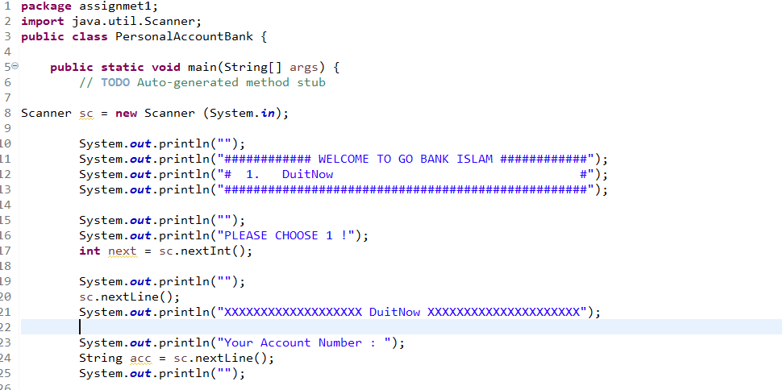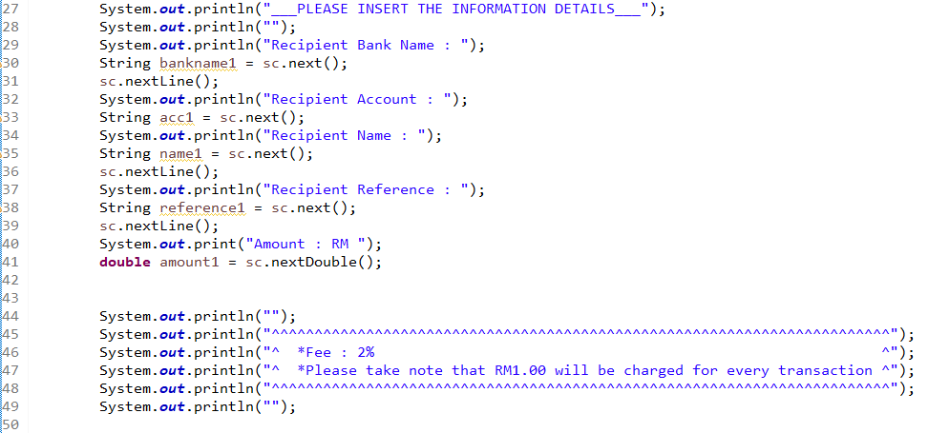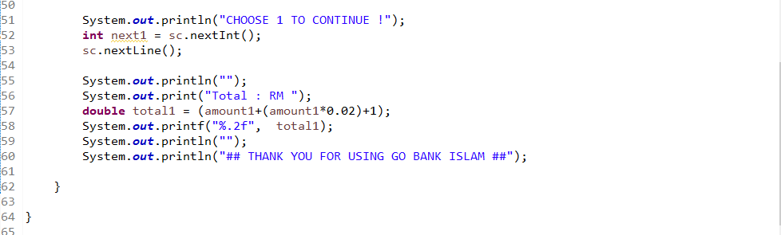

OUTPUT :

